Click on the Incomplete Audits hyperlink to view the contracts that are in incomplete status and need payments confirmed.
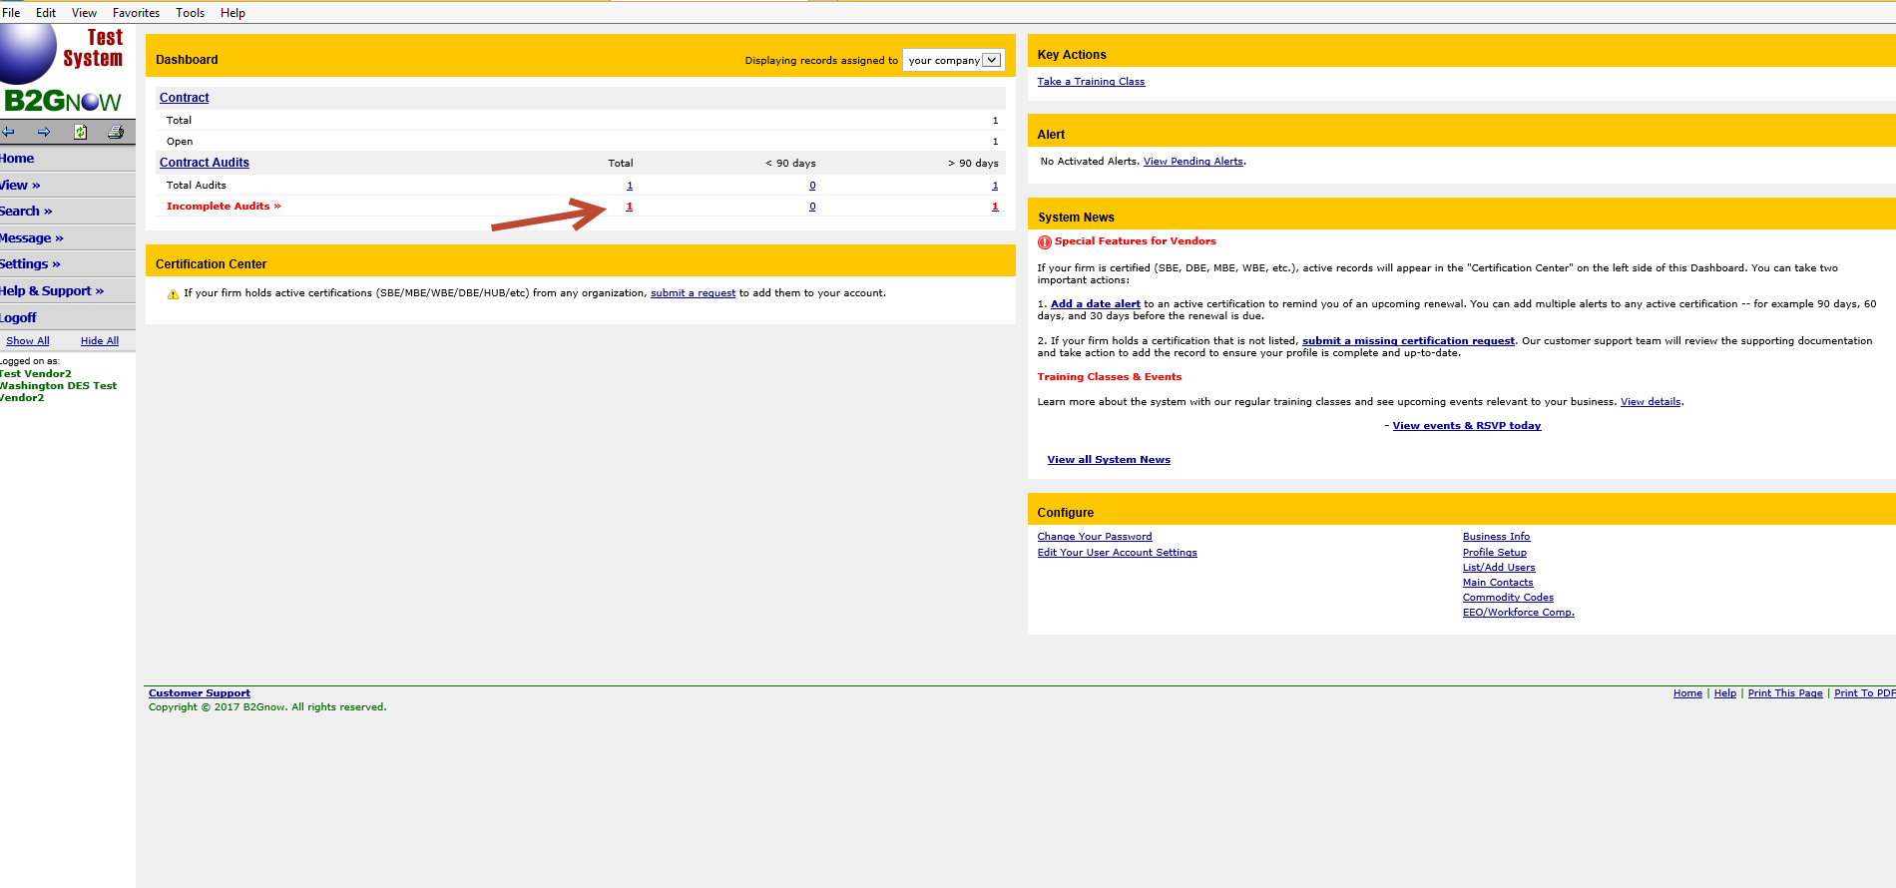

Click on the Incomplete hyperlink to open the contract you want to confirm payments for.

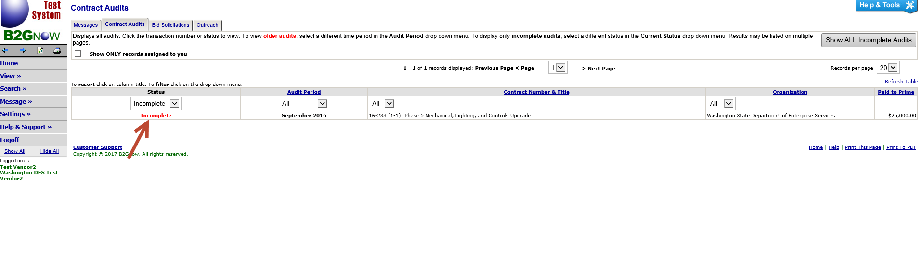

Click on the Confirm Payment Received hyperlink
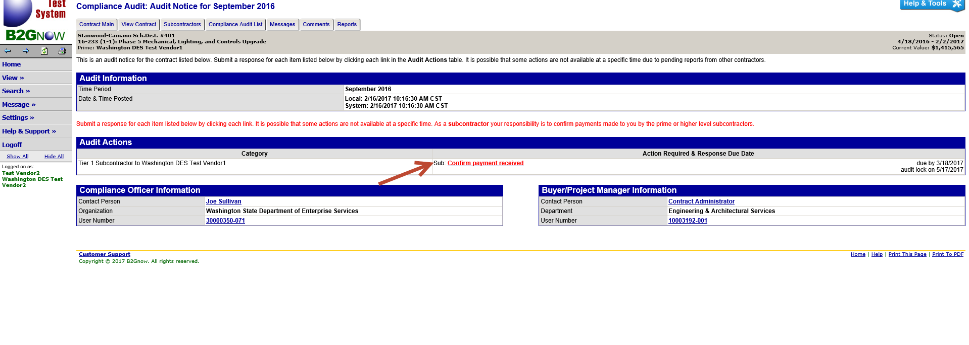

If the payment that was reported by the prime contractor is correct, click on Correct and enter in the Payment Date and select if the payment was prompt or not.
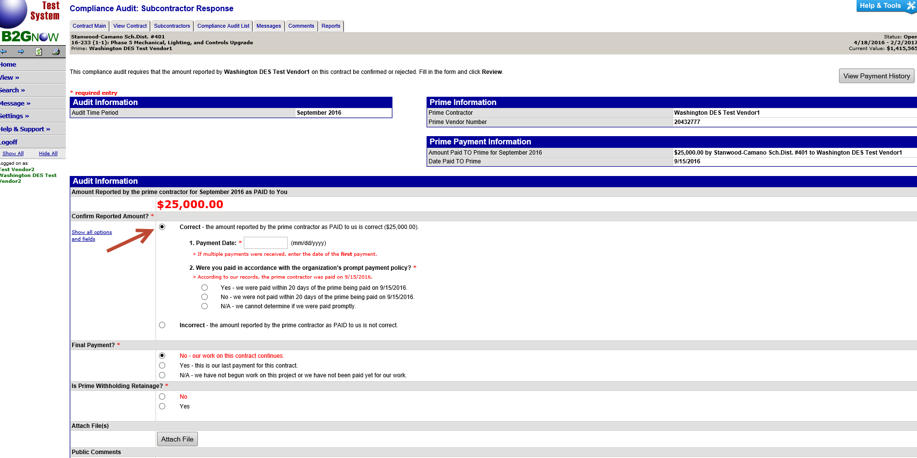

If the payment the prime reported is incorrect, click on Incorrect and then select if you received no payment or were paid a different amount.
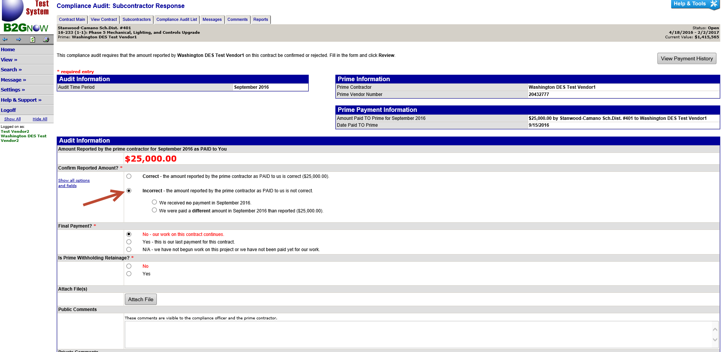

If you were paid a different amount, enter in the Amount, Payment Date and if the payment was Prompt.
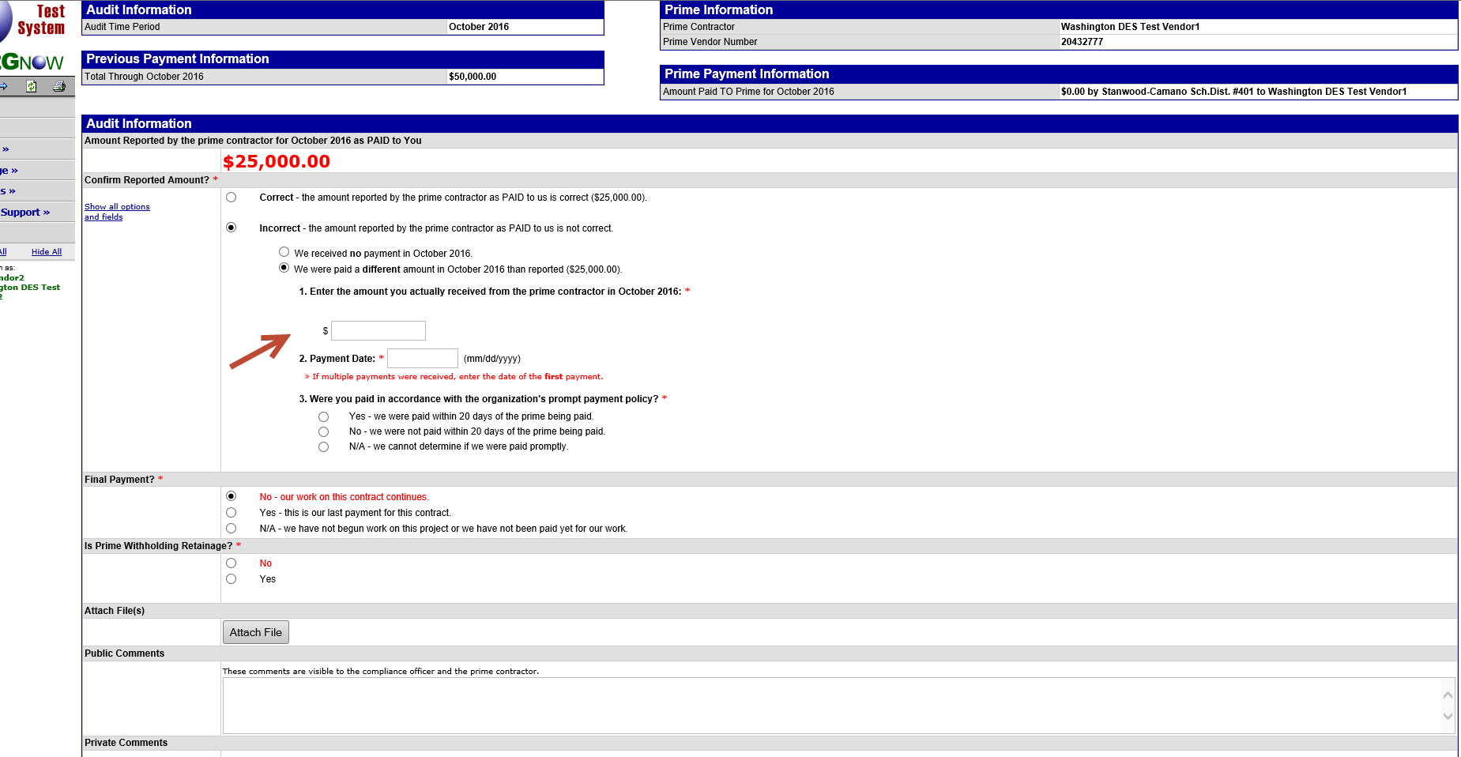

Choose if the payment is final or not and if retainage was held or not.
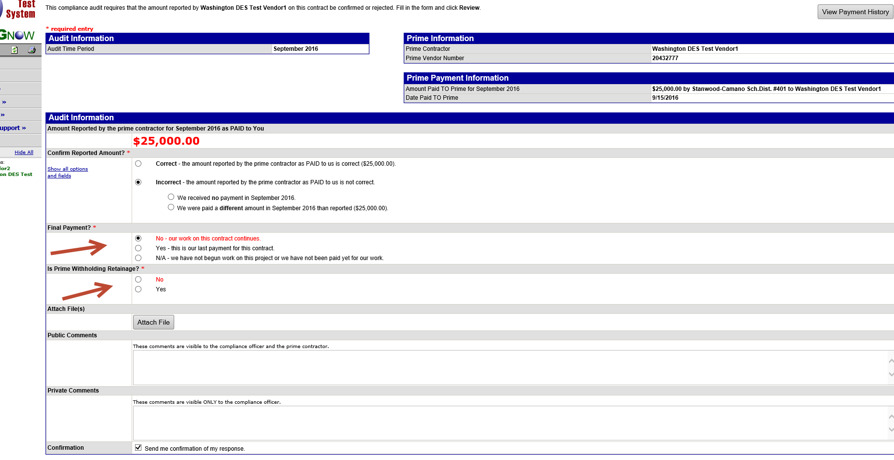

Check the box indicating you are submitting information that is correct and accurate and then click Save.
